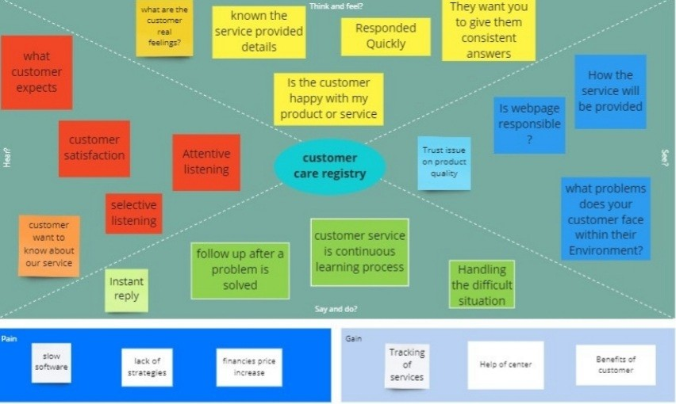

Team Members:

K.Kishor Kumar(1912042)

B.Gobinath (1912009)

M.Subramanian (1912046)

N.Ashvin Jeshril (1912039)